Bullet and Column chart is used to compare one value, represented by a horizontal column, to another value, represented by a horizontal column, and relate those to qualitative ranges.

It has the options to customize the visual as a multi column chart too

Scenario 1: Bullet + Column chart

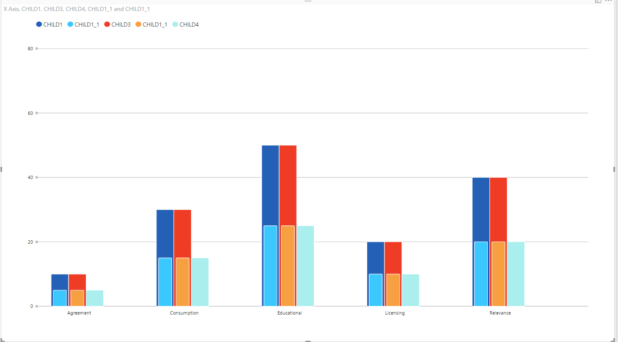

Scenario 2: Multi Column chart

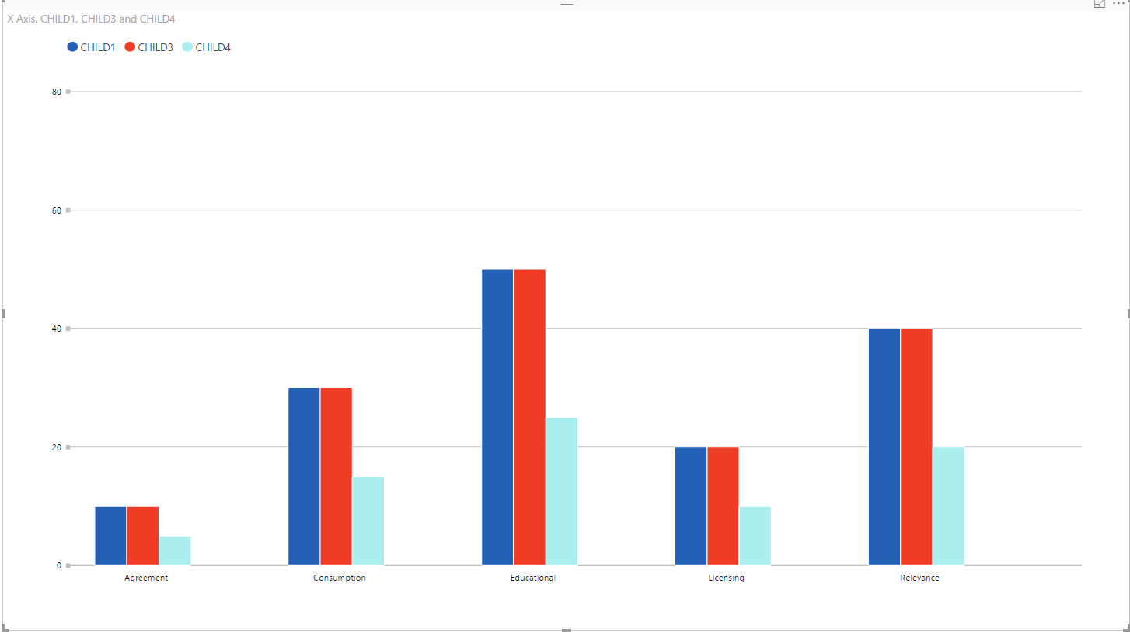

Configurations:

1. Legends:
   1. Enable: To enable legends
   2. Enable click: To make legend clickable for showing/hiding some values by clicking on legends
2. Data Colors: To set colors for columns and bullets
3. X Axis:
   1. Enable Labels: To show/hide labels on X Axis
   2. Font Size: To set font size of X Axis labels
4. Y Axis:
   1. Enable Labels: To show/hide labels on Y Axis
   2. Font Size: To set font size of Y Axis labels